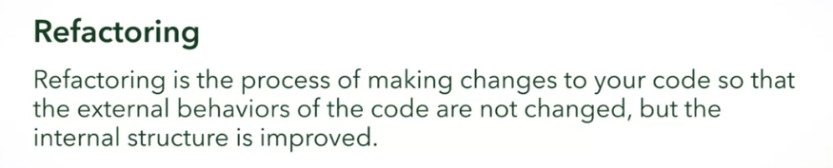



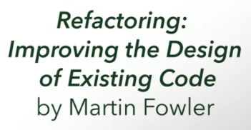

FIRST CODE SMELL



Comments that are indicators of bad code:



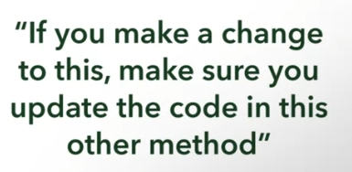

Use of comments

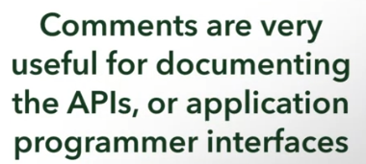

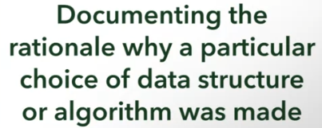

SECOND CODE SMELL



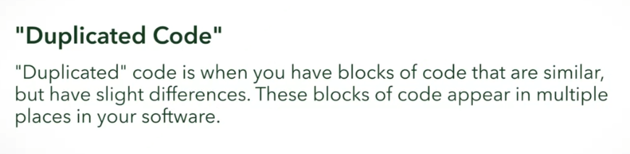

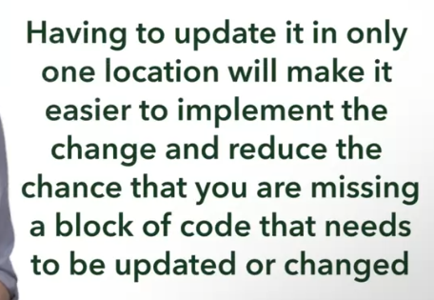

Apply DRY Principle

THIRD CODE SMELL

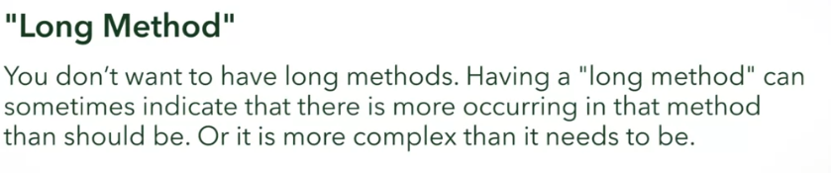

* This is similar to Cognitive Complexity

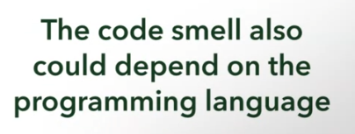

Smalltalk language

* 15 lines

FOURTH CODE SMELL



A.k.a.

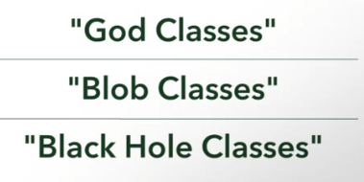

FIFTH CODE SMELL



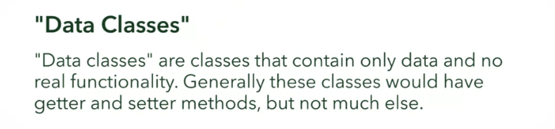

Related issue: SIXTH CODE SMELL



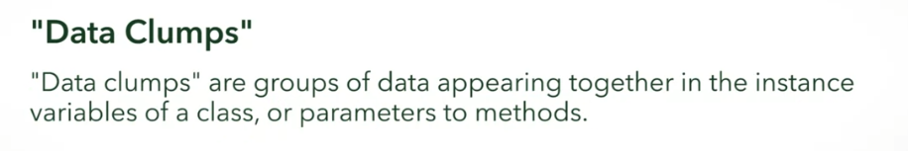

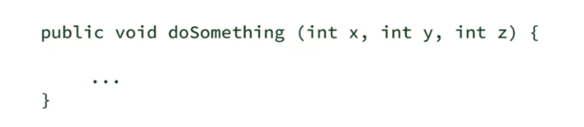

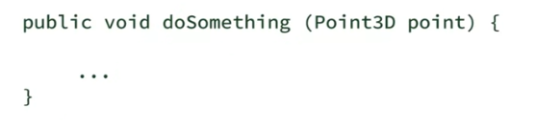

But upon creating the class, you should have methods in the Point3D class to avoid falling into the “Data Classes” code smell

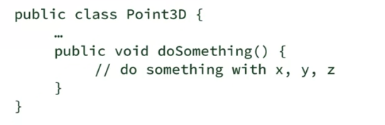

SEVENTH CODE SMELL



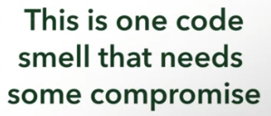

Solutions that are needs compromising:







Main Solution for Long Parameter List:

